TITLE PAGE FILE

This document provides instructions for ensuring proper double-blind peer review of papers submitted to the TEMA Journal on the OJS platform. Compile this document in every part. Authors must follow the submission procedures to ensure content is properly anonymized. This is a crucial step to ensure the integrity of the review process and to respect the confidentiality of the Authors' Work. A submission that does not meet the anonymization criterion cannot be formally accepted, regardless of its quality.

PART 1 - ESSENTIAL INFORMATION

To be compiled and signed by the corresponding Author on behalf of all the authors.
Article Title (Max 20 Words)
Running Title (max 5 words)

Name Surname(a)¹, Name Surname(b)^{2,}*, Name Surname (c)², and Name Surname (d)³.

- Affiliation, Affiliation Country, Email
- Affiliation, Affiliation Country, Email
- Affiliation, Affiliation Country, Email
* Corresponding author. E-mail: name.surname(b)@email.com

ORCID
NSA: xxxx-xxxx-xxxx-xxxx
NSB: xxxx-xxxx-xxxx-xxxx
NSC: xxxx-xxxx-xxxx-xxxx
NSD: xxxx-xxxx-xxxx-xxxx

SUGGESTED REVIEWERS (max 3 names)
ID | NAME | SURNAME | DEPARTMENT | INSTITUTION | COUNTRY | E-MAIL
1 | NAME1 | SURNAME1 | Department 1 | University 1 | CY1 | reviewer1@email.com
2 | NAME2 | SURNAME2 | Department 2 | University 2 | CY2 | reviewer2@email.com
3 | NAME3 | SURNAME3 | Department 3 | University 3 | CY3 | reviewer3@email.com

ACKNOWLEDGMENTS  (max 50 words) | Any acknowledgments to specific research groups or granted projects shall not be mentioned in the anonymous version of your manuscript. Said acknowledgments could only be provided inside this box.

FUNDING  (max 50 words) | Any funding received by the research groups or granted projects shall not be mentioned in the anonymous version of your manuscript. Said Funding could be only provided inside this box.

AUTHOR CONTRIBUTIONS  (max 100 words) | Anyone included in the author list should have their role listed in the author contribution section. If needed, the Authors could follow the CREDiT taxonomy, for which a brief explanation is available at this link (https://credit.niso.org/)  Everyone and only those satisfying one or more of these roles should be included as authors. In addition, all authors must be fully aware of and approve the submission of the manuscript. All author contributions shall not be mentioned in the anonymous version of your manuscript. Said contributions could only be provided inside this box

PART 2 – COVER LETTER

Sample cover letter (the Corresponding Author on behalf of all the co-authors). Rewrite and adapt the red parts.

[Your name – Corresponding Author]
[Your Affiliation]
[Your e-mail Address]

[Date]

Dear TEMA Editorial Board,
I/We wish to submit an original research article entitled “[title of article]” for consideration by TEMA.
I/We confirm that this work is original and has not been published elsewhere, nor is it currently under consideration for publication elsewhere.
In this paper, I/we report on/show that _______. This is significant because __________.
We believe that this manuscript is appropriate for publication by TEMA because it… [specific reference to the journal’s Aims & Scope]. __________.
[Please explain in your own words the significance and novelty of the work, the problem that is being addressed, and why the manuscript belongs in this journal. Do not simply insert your abstract into your cover letter! Briefly describe the research you are reporting in your paper, why it is important, and why you think the readership of the journal would be interested in it.]

We have no conflicts of interest to disclose.

Please address all correspondence concerning this manuscript to me at [email address].
Thank you for your consideration of this manuscript.
Sincerely,
[Your name – Corresponding Author]

To ensure the legal value of this document, I attach a copy of my identity card.
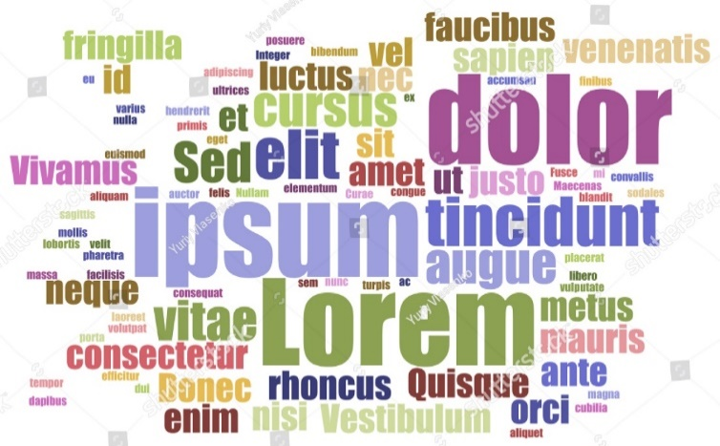

PART 3 - AUTHOR(S) AGREEMENT

The paper listed below has been submitted for publication in the journal TEMA ("Journal"). The signed Agreement gives the Editor of the Journal (the "Editor") permission from the Author ("Author") to evaluate and publish the Work (as defined below). The signed Agreement empowers the Editor to protect the Work against unauthorized use and to maintain its integrity from a bibliographical and archival standpoint. If there are multiple authors of the material governed by this Agreement, the term "Author" as used in this Agreement refers to each and all of them, jointly and severally.

The Editor hereby requests that the Author complete and return this form promptly to the journal manager, uploading it with the paper for peer review, so that the Work may be properly evaluated, revised, and published.

Title of the Contribution (“Work”): Repeat Article Title (Max 20 Words)

1. The Author(s) hereby consent to the publication of the Work in the journal TEMA.
2. The Author(s) warrants that the Work has not been published before in any form except as a preprint, that the Work is not being concurrently submitted to and is not under consideration by another editor, that the persons listed above as Author(s) are listed in the proper order and that no author entitled to credit has been omitted, and generally that the Author(s) has the right to make the grants made to the Editor complete and unencumbered. The Author(s) also warrant that the Work does not libel anyone, infringe anyone’s copyright, or otherwise violate anyone’s rights.
3. The Author(s) grants to TEMA a royalty-free, irrevocable, worldwide, non-exclusive right to publish, reproduce and otherwise copy, in a temporary or permanent way and by any means and in any form, in whole or in part to distribute, transmit, to make available to the public, to display and otherwise use the Work, even if for the first publication, and to create and distribute derivative works, in all formats and media, in print and digital means and by any other means or technology now known or hereafter existing, subject to proper attribution of authorship.
4. This form is to be signed by the Corresponding Author on behalf of all contributors if there is more than one Author.

[Date]

[Your name – Corresponding Author]

[Signature]

PART 4 – IMAGE AUTHORIZATION

The Editor hereby requests that the Author complete and return this form promptly to the journal manager, uploading it with the paper for peer review, so that the Work may be properly evaluated, revised, and published.
The Author of the Work declares the origin of the following images:

Image list (add new lines for more images)
FIGURE NUMBER | IMAGE TYPE | OWNERSHIP | COPYRIGHT | AUTHORIZATION OBTAINED
Fig. 1 | TYPE OF IMAGE | OWNER | YES/NO | WHICH ONE/NOT REQUIRED
Fig. 2
Fig. 3
Fig. 4
Fig. 5
…..
…….
……

An authorization must be presented for each figure who requests it.

- I declare that the text does not contain photographs of artistic-museum works (statues, paintings/frescoes/mosaics).
- I declare that the text contains photographs of artistic-museum works, (statues, paintings/paintings/frescoes/mosaics), and I enclose the property disclaimer.
- I declare that the text does not contain cinematic and advertising images
- I declare that within the text there are no photographs of photographers of authorship.
- I declare that inside the text there are photographs of photographers, and I enclose the photographer’s disclaimer.
- I declare that no photographs have been shot inside or outside the museum
- I declare that photographs have been taken inside and/or outside the museum and I enclose the museum release form.
- I declare that the paper contains photos and/or drawings of the designer and I attach the designer’s disclaimer.

I authorize the publication of the images in the paper titled: “[title of article]” published in TEMA journal.

[Date]

[Your name – Corresponding Author]

[Signature]

Insert Type of Image: Drawing, archive document, picture, and so on.
Declare owner of the Image: Author, archive, photographer, painter, and so on.
Declare whether the Image is copyright protected or not.
Declare whether the Image can be published and under what authorization: Not required, CC-BY, given by the owner and so on. As an author, you are responsible for your declarations.

